Filtering and plots

By this point you have likely downloaded at least a few packages into your R library. The tools in some of these packages can actually be combined and used together to become even more useful. This reading will share a few resources that will teach you how to use the filter function from **dplyr** to make the plots you create with **ggplot2** easier to read.

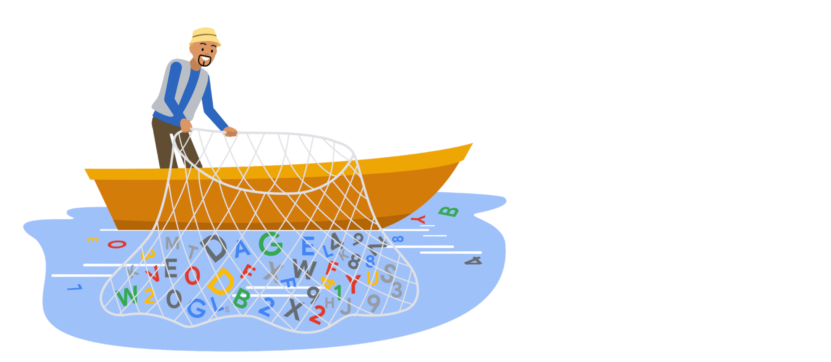

**Example of filtering data for plotting**

Filtering your data before you plot it allows you to focus on specific subsets of your data and gain more targeted insights. To do this, just include the dplyr filter() function in your ggplot syntax.

| **Example code** |
| --- |
| **data %>%    filter(variable1 == "DS") %>%   ggplot(aes(x = weight, y = variable2, colour = variable1)) +   geom_point(alpha = 0.3,  position = position_jitter()) + stat_smooth(method = "lm")** |

**Additional resources**

To learn more details about ggplot2 and filtering with dplyr, check out these resources:

* [**Putting it all together: (dplyr+ggplot)**](https://rladiessydney.org/courses/ryouwithme/03-vizwhiz-1/#1-4-putting-it-all-together-dplyr-ggplot)**:** The RLadies of Sydney’s course on R uses real data to demonstrate R functions. This lesson focuses specifically on combining dplyr and ggplot to filter data before plotting it. The instructional video will guide you through every step in the process while you follow along with the data they have provided.
* [**Data transformation:**](https://r4ds.had.co.nz/transform.html)This resource focuses on how to use the filter() function in R, and demonstrates how to combine filter() with ggplot(). This is a useful resource if you are interested in learning more about how filter() can be used before plotting.
* [**Visualizing data with ggplot2:**](https://datacarpentry.org/dc_zurich/R-ecology/05-visualisation-ggplot2.html) This comprehensive guide includes everything from the most basic uses for ggplot2 to creating complicated visualizations. It includes the filter() function in most of the examples so you can learn how to implement it in R to create data visualizations.